**Program No: 01 Date:16-08-2022**

**Aim**:Develop android application to implement button click using toast.

**Program Code:**

**activity.xml**

*<?*xml version="1.0" encoding="utf-8"*?>*<androidx.constraintlayout.widget.ConstraintLayout xmlns:android="http://schemas.android.com/apk/res/android"  
 xmlns:app="http://schemas.android.com/apk/res-auto"  
 xmlns:tools="http://schemas.android.com/tools"  
 android:layout_width="match_parent"  
 android:layout_height="match_parent"  
 tools:context=".MainActivity">  
  
 <TextView  
 android:layout_width="wrap_content"  
 android:layout_height="wrap_content"  
 android:text="Hello World!"  
 app:layout_constraintBottom_toBottomOf="parent"  
 app:layout_constraintLeft_toLeftOf="parent"  
 app:layout_constraintRight_toRightOf="parent"  
 app:layout_constraintTop_toTopOf="parent" />  
 <Button  
 android:layout_width="wrap_content"  
 android:layout_height="wrap_content"  
 android:id="@+id/btn1"  
 android:textColor="@color/black"  
 android:background="@color/cardview_shadow_end_color"  
 android:text="Button click" />

**mainactivity.java**

package com.example.myapplication;  
  
import androidx.appcompat.app.AppCompatActivity;  
  
import android.os.Bundle;  
import android.view.View;  
import android.widget.Button;  
import android.widget.Toast;  
  
public class MainActivity extends AppCompatActivity {  
  
 @Override  
 protected void onCreate(Bundle savedInstanceState) {  
 super.onCreate(savedInstanceState);  
 setContentView(R.layout.*activity_main*);  
 Button b=findViewById(R.id.*btn1*);  
 b.setOnClickListener(new View.OnClickListener() {  
 @Override  
 public void onClick(View view) {  
 Toast.*makeText*(getApplicationContext(),"buttonclicked",Toast.*LENGTH_LONG*).show();  
 }  
 });  
 }  
  
 }

**OUTPUT**

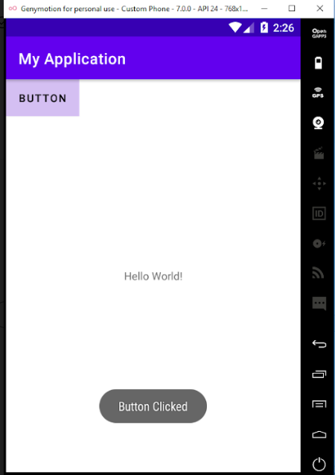

**Program No: 02 Date:19-08-2022**

**Aim**:Develop android application to implement button click using toast.

**Program Code:**

**activity.xml**

*<?*xml version="1.0" encoding="utf-8"*?>*<LinearLayout  
 xmlns:android="http://schemas.android.com/apk/res/android"  
 xmlns:app="http://schemas.android.com/apk/res-auto"  
 xmlns:tools="http://schemas.android.com/tools"  
 android:layout_width="match_parent"  
 android:layout_height="match_parent"  
 tools:context=".MainActivity"  
 android:orientation="vertical">  
  
 <TextView  
 android:layout_width="wrap_content"  
 android:layout_height="wrap_content"  
 android:text="Login"  
 android:textSize="@dimen/cardview_default_radius"/>  
  
 <EditText  
 android:layout_width="match_parent"  
 android:layout_height="wrap_content"  
 android:hint="username"  
 android:id="@+id/et1"  
 />  
 <EditText  
 android:layout_width="match_parent"  
 android:layout_height="wrap_content"  
 android:hint="password"  
 android:id="@+id/et2"  
 android:layout_marginTop="10dp"  
 android:inputType="textPassword"  
 />  
 <Button  
 android:layout_width="wrap_content"  
 android:layout_height="wrap_content"  
 android:text="Login"  
 android:id="@+id/btn"  
 android:layout_marginLeft="140dp"  
 />

</LinearLayout>

**Mainactivity.java**

package com.example.pgm2;  
import androidx.appcompat.app.AppCompatActivity;  
  
import android.os.Bundle;  
import android.view.View;  
import android.widget.Button;  
import android.widget.EditText;  
import android.widget.Toast;  
  
public class MainActivity extends AppCompatActivity {  
  
 @Override  
 protected void onCreate(Bundle savedInstanceState) {  
 super.onCreate(savedInstanceState);  
 setContentView(R.layout.*activity_main*);  
 EditText et1=findViewById(R.id.*et1*);  
 EditText et2=findViewById(R.id.*et2*);  
 Button button=findViewById(R.id.*btn*);  
button.setOnClickListener(new View.OnClickListener() { @Override  
 public void onClick(View view) {  
 validate(et1.getText().toString(),et2.getText().toString());  
 }  
 private void validate(String us,String pw)  
 {  
 if(us.equals("admin")&&pw.equals("1234"))  
 {  
 Toast.*makeText*(getApplicationContext(),"Login successfull",Toast.*LENGTH_LONG*).show();  
 }  
 else  
 {  
 Toast.*makeText*(getApplicationContext(),"Unsuccessfull login",Toast.*LENGTH_LONG*).show();  
 }  
 }  
 });  
 }  
}

**Output**

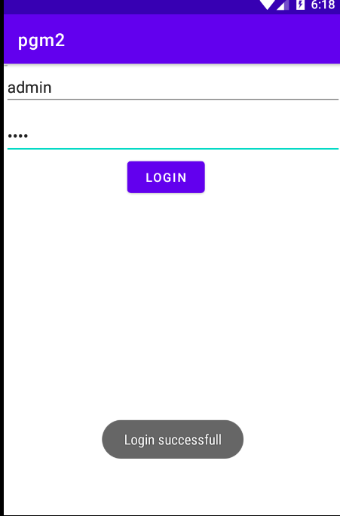

**Program No: 03 Date:19-08-2022**

**Aim**:

**Program Code:**

**activity.xml**

*<?*xml version="1.0" encoding="utf-8"*?>*<androidx.constraintlayout.widget.ConstraintLayout xmlns:android="http://schemas.android.com/apk/res/android"  
 xmlns:app="http://schemas.android.com/apk/res-auto"  
 xmlns:tools="http://schemas.android.com/tools"  
 android:layout_width="match_parent"  
 android:layout_height="match_parent"  
 tools:context=".MainActivity">  
  
 <TextView  
 android:layout_width="wrap_content"  
 android:layout_height="wrap_content"  
 android:text="Hello World!"  
 app:layout_constraintBottom_toBottomOf="parent"  
 app:layout_constraintLeft_toLeftOf="parent"  
 app:layout_constraintRight_toRightOf="parent"  
 app:layout_constraintTop_toTopOf="parent" />  
  
</androidx.constraintlayout.widget.ConstraintLayout>

**Mainactivity.java**

package com.example.pgm3;  
  
import androidx.appcompat.app.AppCompatActivity;  
  
import android.os.Bundle;  
import android.util.Log;  
  
public class MainActivity extends AppCompatActivity {  
  
 @Override  
 protected void onCreate(Bundle savedInstanceState) {  
 super.onCreate(savedInstanceState);  
 setContentView(R.layout.*activity_main*);  
 Log.*d*("lifecycle","onCreate invoked");  
 }  
  
 @Override  
 protected void onStart() {  
 super.onStart();  
 Log.*d*("lifecycle","onStart invoked");  
 }  
  
 @Override  
 protected void onResume() {  
 super.onResume();  
 Log.*d*("lifecycle","onResume invoked");  
 }  
  
 @Override  
 protected void onPause() {  
 super.onPause();  
 Log.*d*("lifecycle","onPause invoked");  
 }  
  
 @Override  
 protected void onStop() {  
 super.onStop();  
 Log.*d*("lifecycle","onStop invoked");  
 }  
  
 @Override  
 protected void onRestart() {  
 super.onRestart();  
 Log.*d*("lifecycle","onRestart invoked");  
 }  
  
 @Override  
 protected void onDestroy() {  
 super.onDestroy();  
 Log.*d*("lifecycle","onDestroy invoked");  
 }  
}

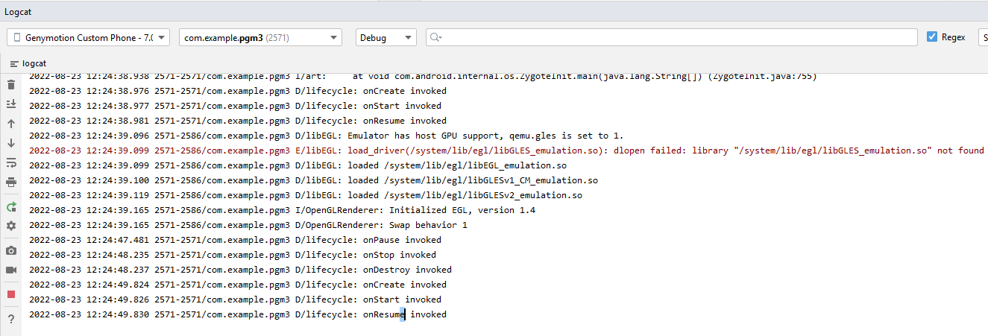

**Program No: 04 Date:26-08-2022**

**Aim**:

**Program Code:**

**activity.xml**

*<?*xml version="1.0" encoding="utf-8"*?>*<LinearLayout  
 xmlns:android="http://schemas.android.com/apk/res/android"  
 xmlns:app="http://schemas.android.com/apk/res-auto"  
 xmlns:tools="http://schemas.android.com/tools"  
 android:layout_width="match_parent"  
 android:layout_height="match_parent"  
 tools:context=".MainActivity"  
 android:orientation="vertical">  
  
 <TextView  
 android:layout_width="wrap_content"  
 android:layout_height="wrap_content"  
 android:text="Simple Calculator" />  
 <TextView  
 android:layout_width="match_parent"  
 android:layout_height="wrap_content"  
 android:text="Enter 1st number"/>  
 <EditText  
 android:layout_width="wrap_content"  
 android:layout_height="wrap_content"  
 android:hint="Enter 1st number"  
 android:id="@+id/n1"/>  
 <TextView  
 android:layout_width="match_parent"  
 android:layout_height="wrap_content"  
 android:text="Enter 2nd number"/>  
 <EditText  
 android:layout_width="wrap_content"  
 android:layout_height="wrap_content"  
 android:hint="Enter 2nd number"  
 android:id="@+id/n2"/>  
 <TextView  
 android:layout_width="wrap_content"  
 android:layout_height="wrap_content"  
 android:id="@+id/t1"/>  
 <LinearLayout  
 android:layout_width="wrap_content"  
 android:layout_height="wrap_content">  
 <Button  
 android:layout_width="wrap_content"  
 android:layout_height="wrap_content"  
 android:text="Add"  
 android:id="@+id/b1"/>  
 <Button  
 android:layout_width="wrap_content"  
 android:layout_height="wrap_content"  
 android:text="Sub"  
 android:id="@+id/b2"/>  
 <Button  
 android:layout_width="wrap_content"  
 android:layout_height="wrap_content"  
 android:text="Mul"  
 android:id="@+id/b3"/>  
 <Button  
 android:layout_width="wrap_content"  
 android:layout_height="wrap_content"  
 android:text="Div"  
 android:id="@+id/b4"/>  
 </LinearLayout>  
  
  
  
</LinearLayout>

**Mainactivity.java**

package com.example.pgm4;  
  
import androidx.appcompat.app.AppCompatActivity;  
  
import android.os.Bundle;  
import android.view.View;  
import android.widget.Button;  
import android.widget.EditText;  
import android.widget.TextView;  
  
public class MainActivity extends AppCompatActivity {  
  
 @Override  
 protected void onCreate(Bundle savedInstanceState) {  
 super.onCreate(savedInstanceState);  
 setContentView(R.layout.*activity_main*);  
 EditText t1=findViewById(R.id.*n1*);  
 EditText t2=findViewById(R.id.*n2*);  
 Button add=findViewById(R.id.*b1*);  
 Button sub=findViewById(R.id.*b2*);  
 Button mul=findViewById(R.id.*b3*);  
 Button div=findViewById(R.id.*b4*);  
 TextView tv1=findViewById(R.id.*t1*);  
  
 add.setOnClickListener(new View.OnClickListener() {  
 @Override  
 public void onClick(View view) {  
 Double a1=Double.*parseDouble*(t1.getText().toString());  
 Double a2=Double.*parseDouble*(t2.getText().toString());  
 Double r=a1+a2;  
 tv1.setText("Result is: "+String.*valueOf*(r));  
 }  
 });  
 sub.setOnClickListener(new View.OnClickListener() {  
 @Override  
 public void onClick(View view) {  
 Double s1=Double.*parseDouble*(t1.getText().toString());  
 Double s2=Double.*parseDouble*(t2.getText().toString());  
 Double r=s1-s2;  
 tv1.setText("Result is: "+String.*valueOf*(r));  
 }  
 });  
 mul.setOnClickListener(new View.OnClickListener() {  
 @Override  
 public void onClick(View view) {  
 Double m1=Double.*parseDouble*(t1.getText().toString());  
 Double m2=Double.*parseDouble*(t2.getText().toString());  
 Double r=m1*m2;  
 tv1.setText("Result is: "+String.*valueOf*(r));  
 }  
 });  
 div.setOnClickListener(new View.OnClickListener() {  
 @Override  
 public void onClick(View view) {  
 Double d1=Double.*parseDouble*(t1.getText().toString());  
 Double d2=Double.*parseDouble*(t2.getText().toString());  
 Double r=d1/d2;  
 tv1.setText("Result is: "+String.*valueOf*(r));  
 }  
 });  
 }  
  
}

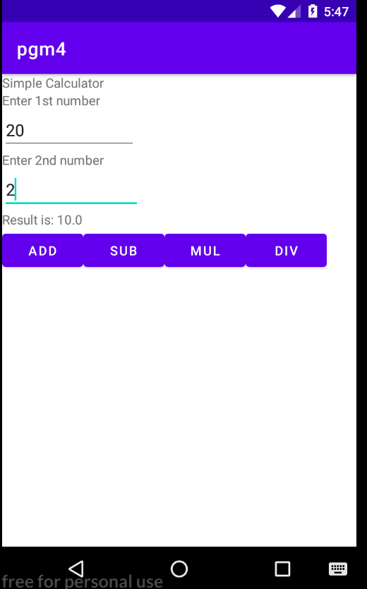

**Program No: 05 Date:14-09-2022**

**Aim**:

**Program Code:**

**Activity_main.xml**

*<?*xml version="1.0" encoding="utf-8"*?>*<LinearLayout  
 xmlns:android="http://schemas.android.com/apk/res/android"  
 xmlns:app="http://schemas.android.com/apk/res-auto"  
 xmlns:tools="http://schemas.android.com/tools"  
 android:layout_width="match_parent"  
 android:layout_height="match_parent"  
 tools:context=".MainActivity"  
 android:orientation="vertical">  
  
 <TextView  
 android:layout_width="wrap_content"  
 android:layout_height="wrap_content"  
 android:text="User Name"  
 app:layout_constraintBottom_toBottomOf="parent"  
 app:layout_constraintLeft_toLeftOf="parent"  
 app:layout_constraintRight_toRightOf="parent"  
 app:layout_constraintTop_toTopOf="parent" />  
 <EditText  
 android:layout_width="wrap_content"  
 android:layout_height="wrap_content"  
 android:hint="Enter username">  
 </EditText>  
 <TextView  
 android:layout_width="wrap_content"  
 android:layout_height="wrap_content"  
 android:text="Password"  
 app:layout_constraintBottom_toBottomOf="parent"  
 app:layout_constraintLeft_toLeftOf="parent"  
 app:layout_constraintRight_toRightOf="parent"  
 app:layout_constraintTop_toTopOf="parent" />  
 <EditText  
 android:layout_width="wrap_content"  
 android:layout_height="wrap_content"  
 android:hint="Enter password">  
 </EditText>  
 <LinearLayout  
 android:layout_width="wrap_content"  
 android:layout_height="wrap_content">  
 <Button  
 android:layout_width="wrap_content"  
 android:layout_height="wrap_content"  
 android:text="SignIn"  
 android:id="@+id/btn1"  
 android:onClick="welcome">  
 </Button>  
 <Button  
 android:layout_width="wrap_content"  
 android:layout_height="wrap_content"  
 android:text="SignUp"  
 android:id="@+id/btn2"  
 android:onClick="registration">  
 </Button>  
 </LinearLayout>  
</LinearLayout>

**MainActivity.java**

package com.example.pgm5;  
  
import androidx.appcompat.app.AppCompatActivity;  
  
import android.os.Bundle;  
import android.view.View;  
  
public class MainActivity extends AppCompatActivity {  
  
 @Override  
 protected void onCreate(Bundle savedInstanceState) {  
 super.onCreate(savedInstanceState);  
 setContentView(R.layout.*activity_main*);  
 }  
 public void welcome(View v)  
 {  
 setContentView(R.layout.*activity_welcome*);  
 }  
 public void registration(View v)  
 {  
 setContentView(R.layout.*activity_registration*);  
 }  
}

**activity_welcome.xml**

*<?*xml version="1.0" encoding="utf-8"*?>*<LinearLayout  
 xmlns:android="http://schemas.android.com/apk/res/android"  
 xmlns:app="http://schemas.android.com/apk/res-auto"  
 xmlns:tools="http://schemas.android.com/tools"  
 android:layout_width="match_parent"  
 android:layout_height="match_parent"  
 tools:context=".welcome"  
 android:orientation="vertical">  
 <TextView  
 android:layout_width="wrap_content"  
 android:layout_height="wrap_content"  
 android:text="You have signed in">  
 </TextView>  
</LinearLayout>

**welcome.java**

package com.example.pgm5;  
  
import androidx.appcompat.app.AppCompatActivity;  
  
import android.os.Bundle;  
  
public class welcome extends AppCompatActivity {  
  
 @Override  
 protected void onCreate(Bundle savedInstanceState) {  
 super.onCreate(savedInstanceState);  
 setContentView(R.layout.*activity_welcome*);  
 }  
}

**activity_registration.xml**

*<?*xml version="1.0" encoding="utf-8"*?>*<LinearLayout  
 xmlns:android="http://schemas.android.com/apk/res/android"  
 xmlns:app="http://schemas.android.com/apk/res-auto"  
 xmlns:tools="http://schemas.android.com/tools"  
 android:layout_width="match_parent"  
 android:layout_height="match_parent"  
 tools:context=".registration"  
 android:orientation="vertical">  
 <TextView  
 android:layout_width="wrap_content"  
 android:layout_height="wrap_content"  
 android:text="Enter Your Name">  
 </TextView>  
 <EditText  
 android:layout_width="wrap_content"  
 android:layout_height="wrap_content"  
 android:hint="Enter your name">  
 </EditText>  
 <TextView  
 android:layout_width="wrap_content"  
 android:layout_height="wrap_content"  
 android:text="Enter Your Email Id">  
 </TextView>  
 <EditText  
 android:layout_width="wrap_content"  
 android:layout_height="wrap_content"  
 android:hint="Enter Your Email Id">  
 </EditText>  
 <TextView  
 android:layout_width="wrap_content"  
 android:layout_height="wrap_content"  
 android:text="Enter Your Phone Number">  
 </TextView>  
 <EditText  
 android:layout_width="wrap_content"  
 android:layout_height="wrap_content"  
 android:hint="Enter Your Phone Number">  
 </EditText>  
  
  
 <TextView  
 android:layout_width="wrap_content"  
 android:layout_height="wrap_content"  
 android:text="Enter Your Address">  
 </TextView>  
 <EditText  
 android:layout_width="wrap_content"  
 android:layout_height="wrap_content"  
 android:hint="Enter Your Address">  
 </EditText>  
 <TextView  
 android:layout_width="wrap_content"  
 android:layout_height="wrap_content"  
 android:text="Gender">  
 </TextView>  
  
 <RadioGroup  
 android:layout_width="wrap_content"  
 android:layout_height="wrap_content">  
 <RadioButton  
 android:layout_width="wrap_content"  
 android:layout_height="wrap_content"  
 android:text="Female">  
 </RadioButton>  
 <RadioButton  
 android:layout_width="wrap_content"  
 android:layout_height="wrap_content"  
 android:text="Male">  
 </RadioButton>  
 </RadioGroup>  
 <Button  
 android:layout_width="wrap_content"  
 android:layout_height="wrap_content"  
 android:text="Submit">  
 </Button>  
</LinearLayout>

**Registration.java**

package com.example.pgm5;  
  
import androidx.appcompat.app.AppCompatActivity;  
  
import android.os.Bundle;  
  
public class registration extends AppCompatActivity {  
  
 @Override  
 protected void onCreate(Bundle savedInstanceState) {  
 super.onCreate(savedInstanceState);  
 setContentView(R.layout.*activity_registration*);  
 }  
}